Software Requirements Specification
for
Registration System
Version 1.0 approved
Prepared by Selina Rodriguez
Ashford University
January 25, 2021
Table of Contents
Table of Contents ii
Revision History ii
1. Introduction 1
1.1 Purpose 1
1.2 Scope 1
1.3 Intended Audience and Reading Suggestions 1
1.4 Definitions and abbreviations 1
1.5 References 1
1.6 Overview 1
2. Overall Description 2
2.1 Product Perspective 2
2.2 Product Functions 2
2.3 User Characteristics 2
2.4 Constraints 2
2.5 Assumptions and Dependencies 3
3. Specific Requirements 3
3.1 External Interfaces 3
3.2 User Interfaces 3
3.3 Hardware Interfaces 3
3.4 Software Interfaces 3
3.5 Communications Interfaces 3
3.2 Functional Requirments 3
3.2.1 New User registration 3
3.2.2 Unique User ID and password 3
3.2.3 User information should have key indentifiers 3
3.2.4 Post Users can access system 3
3.2.5 Students can list courses 3
3.2.6 Each course will have a mamium count based on course 3
3.2.7 User can add themselves to waiting list for full course 3
3.2.8 User can cancel enrollment from course 3

6. Other Requirements 5
Appendix A: Glossary 5
Appendix B: Analysis Models 5
Appendix C: To Be Determined List 6

Revision History
Name | Date | Reason For Changes | Version
Selina Rodriguez | 12/14/20
Selina Rodriguez | 01/25/21 | Instructor feedback | 1.2

Introduction

Purpose
The purpose of this software design specification is made with the intention of outlining the software architecture and software design of the student registrations system. This document will provide the key requirements requested for students having the ability to register for online courses and select between different courses offered in different semesters also courses having a max capacity and be able to enroll on the waitlist if max capacity is reached.

Scope
The student registration system will demonstrate the functional and nonfunctional requirements that meet the key requirements for the student registration system. This document will provide the database design, the design patterns, class diagram, use case diagram and sequence diagram.

Intended Audience and Reading Suggestions
The intended audience is mainly for the developers, the stakeholders and the administrators.

Product Scope
Course Name: courseName
Course Code: courseCode

User ID: User_id
User Email: user_email

References
Tsui, F., Karam, O., & Bernal, B. (2018). Essentials of software engineering (4th ed.). Jones & Bartlett Learning.

Overall Description

Product Perspective
The registration system will be used using the XAMPP local web server to run PHP and MSQL on the local computer. The product will allow students to register for courses and access their profile with their course registration information.

Product Functions
The course registration system will allow student to enroll themselves to register and enroll into courses based on the course availability in the semester.

Th system will allow them access once registered to enroll in courses.

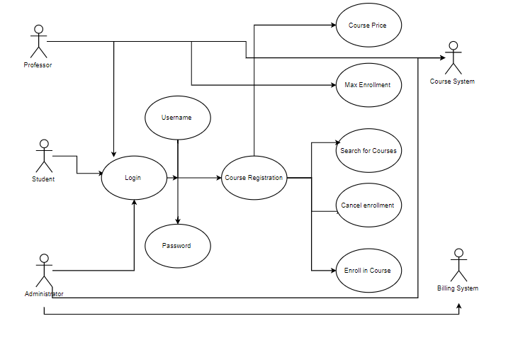

User Classes and Characteristics
Students will be able to use the application once registered in the system and be able enroll in courses. The student cannot enroll in courses unless registered.

Operating Environment
The application is hosted on the local server using XAMPP to run the PHP code and access MySQL database.

Design and Implementation Constraints
The application can only be accessed on the local machine on the localhost to function the page. The page is not available if there is not a local server used.

User Documentation
A final copy will be provided for the users that will maintain the software and will detail how to maintain the software.

Assumptions and Dependencies
This site cannot but run unless using a local server to run the PHP code and access the database.

External Interface Requirements

User Interfaces
The user will register

– Register
First Name:
Last Name:
Email Address:
Password:
Address:
Phone:

– Log In
Email Address:
Password:

Hardware Interfaces
Computer
Local Web Server

Software Interfaces
- XAMPP
- PhpMyAdmin
- MySQL

Communications Interfaces
Having access to a computer and a local web server and source code editor to write php code.

